Mojtaba Ammari-Allahyari
Academic Development Team - Coventry University
Creativity & Enterprise

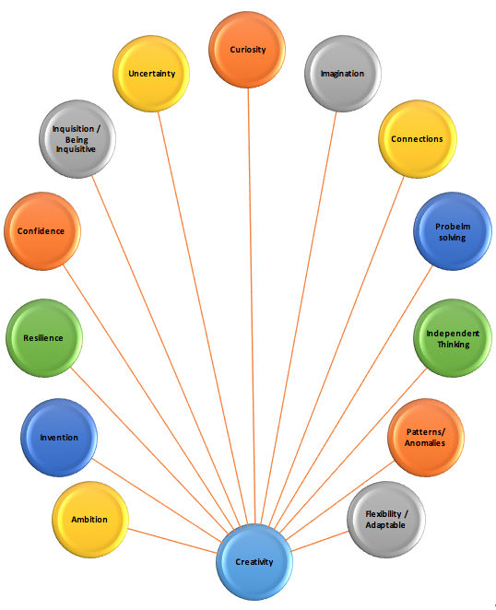
Table of Contents
Creativity & Enterprise in Coventry University Education Strategy 3
Creativity & Enterprise 4
Creativity 4
Enterprise 5
CQEM report from the faculties 6
Suggestions 6
References 6
Useful links 6

“Whatever you do, if you do it joyfully, if you do it lovingly, then it is creative.”

Creativity & Enterprise in Coventry University Education Strategy
Creativity & Enterprise is one of the six pillars of Coventry University educat8ion strategy. According to the University strategy and vision of transformative learning, all University “courses encourage students to develop creativity, critical enquiry, reflective practice and to understand the tools to independently manage their own continuous learning” (CU Education Strategy, p.4). That means our students and graduates are expected to showcase an awareness of the main characteristics and elements of creative performance, creative thinking, and creative modelling. This in turn, will provide them the opportunity of being a successful entrepreneur in case they want to run their own business or be a part an organisation. Creativity is one the most important skills in higher education. This skill intertwined with many other crucial skills like problem-solving, being inquisitive, being confident and ambitious, ability of working independently and within a group, etc.
Employers can and are influencing the way universities prepare students for their future careers. This has a direct effect on all teaching & learning activities related to creativity and enterprise within the University faculties and schools. Coventry University education strategy clearly emphasises on the importance of the main characteristic and elements of creativity and enterprise from both student experience and teaching & learning perspectives. With regards to student experience it says: “Through teaching and assessment Coventry University provides a safe environment in which new ideas can be tested and students are able to develop enterprise or entrepreneur skills.” It also highlighted the importance of C&E in every course of the University: “Every course has space to encourage enterprise and entrepreneurship within the classroom and beyond formal learning environments.” (CU education Strategy, p.5)
Six pillars of transformative learning in education strategy are shown below. All six pillars are tightly intertwined to provide transformative learning experience for all of our students “to make significant contributions to their professions and communities and be a creative force in a rapidly evolving world.” (CU Education Strategy, p.4) However, creativity and enterprise pillar has a vital role in order to achieve our strategy goals. Without creative teaching & learning we cannot be expecting that our teaching will be inspired by teaching, or we can successfully embed employability into the University courses. Also innovation and digital fluency and how this can be injected into teaching and learning is extremely depends on the creative strategy and tactics in all aspects of teaching, learning, and assessment at the faculty levels. This very specific pillar is very much involved in all the other pillars and for this reason in this document I first tried to introduce what creativity and enterprise are, I then reviewed the University faculties CQEM report on creativity and enterprise and finally the last section of this document discusses the suggestions in line with the goals and targets of the University education strategy.

Creativity & Enterprise
Although creativity and enterprise are intertwined concepts, but, compare with creativity which is very much linked with every aspect of our everyday life, enterprise is more business dominated term. In this document enterprise refers to “being innovative in exploring personal and organization opportunities, by adopting a particular approach to work, study or life in general; and being enterprising and becoming more independent and self-reliant throughout life, by gaining the necessary knowledge, skills and attitudes” (Lowe & Marriott, 2012). Enterprise education is defined as “the process of equipping students (or graduates) with an enhanced capacity to generate ideas and the skills to make them happen” (QAA, 2012). This is very much twisted with what we perhaps consider as a creative process. This is followed by definition of entrepreneurship education as the process which “equips students with the additional knowledge, attributes and capabilities required to apply these abilities in the context of setting up a new venture or business” (ibid, p.2). And both definition lead us to definition of entrepreneurial effectiveness as “the ability to function effectively as an entrepreneur or in an entrepreneurial capacity, for example within small businesses or as part of ‘portfolio careers, where multiple job opportunities, part time work and personal ventures combine.’ Enterprise and entrepreneurship are transdisciplinary, with a string connection to issues of employability, innovation, knowledge transfer, commercialisation, and intellectual property.”(ibid., p.2)

“The most important stage of any enterprise is the beginning.” Plato

Creativity
It is not easy to define creativity. It is related to a plenty of our thoughts, actions, and activities. Overall, it can be defined as the ability of generating/recognizing new and imaginative ideas, connecting them with others to reveal/create some hidden patterns or anomalies and turning them into reality or using them in a problem solving situation. The following map shows the concepts and skills which were used to put the above definition together:

The ability of thinking outside the box and seeing things from different perspective, being flexible and adaptable in an uncertain situation, being inquisitive and asking effective questions, the ability to work with others as well as working independently, maintain motivated and ambitious, … all and all are the main characteristics of creativity and being creative.
When it comes to teaching and learning all these aspects are going to be considered from teaching & learning perspective to provide an educational environment in which not only educators perform creatively but also their delivery could create the environment in which students could develop their creativity skills and also being creative in their daily life practice as a student and more importantly as a citizen of the global world.

Enterprise
21st century needs, created a very competitive situation for graduate to secure good job roles. This also has a great impact on universities teaching & learning methods and materials to provide students and graduates not with just their academic degree but with the tools, skills and knowledge that they could live, participate, and contribute as global citizens. For this reason, throughout design of our education strategy some large and small businesses representatives were consulted and given the chance to comment on independent learning and employability skills and issues. Their suggested that “universities have a role that is much more than that teaching the academic content to enable a student to become a graduate.” (CU Education strategy, p.39) The academic degree and certain level of knowledge is a must for graduate “but they also need to know how to think”, “motivated and self-driven” (ibid., p.40) Students need to be given the opportunity to do things for themselves rather than receiving everything done for them. This will encourage them to think outside the box and enable them to deal with new scenarios in their job interviews or any sort of problem-solving activities.
Their comments support University approach to enterprise, innovation and creativity and the CU contribution “to the economic prosperity and knowledge society of Coventry and Warwickshire, the UK and the international economy.” (Creating Better Futures, Corporate Strategy, p.17)

Coventry University aims to “develop large-scale initiative with key partner companies and other organisations, both in the UK and overseas”. The University as an entrepreneurial university, will continue “embedding of entrepreneurship and social enterprise within our educational programmes and employability provision.”
The image below shows six pillars of Enterprise and Innovation:

(CU Corporate Strategy – Creating Better Futures. P.17)

“Creativity is just connecting things. When you ask creative people how they did something, they feel a little guilty because they didn't really do it, they just saw something. It seemed obvious to them after a while. That's because they were able to connect experiences they've had and synthesize new things.” Steve Jobs

CQEM report from the faculties
This section concentrated the faculties submissions on section 2 of CQEM report for Creativity & Enterprise. Depending to the nature and structure of the courses in different faculties there are a wide range of strategies and tactics are introduced and taken place by the course directors to support and embed creativity and enterprise into the course material and promote students’ creativity and entrepreneurial skills. The faculty CQEM submissions with regards to creativity and enterprise addresses the following six areas:

Creativity & Enterprise

- Are students given access to programmes and services to support creativity and enterprise? Give examples
- How is creativity encouraged?
- What links have been made with invited guests (including alumni) to share entrepreneurial experience?
- How is the learning enhanced by the sharing of staff experience and background?
- Demonstrate how the course includes professional projects that enable student creativity?

Faculty of Art & Design and Humanities (FAH)

FAH – Art & Design
Students of Art & Design course were provided a wide range of activities and projects all through their study. Due to the nature of the course creativity elements were beautifully embedded within the course and students were encouraged to engage by taking part in the fashion shows and industries such as JLR, Leverhulme, BW, M&S. By live project briefs students had the opportunity of gaining real world experience in fashion marketing, merchandising and sales. The projects and activities were designed and embedded such that students could develop their creativity and enterprise skills at both individual and team working levels. Students in Architecture course were provided the opportunity of working in studio modules in which the relevant projects support creativity skills. Overall due to the creative nature of the courses in the faculty Art and design there were plenty of activities such as on-sire creative futures, project-based activities, engagement in exhibitions supported embedding elements of creativity into the course to enhance creativity skills of students. Likewise, with regards to enterprise course directors by inviting external speakers, returning alumni, integrating entrepreneurial projects and similar activities provide students with the opportunity of improving their entrepreneurial skills. (See Appendices 1&2 for a sample submission of FAH).

FAH – Humanities
Due to the nature of the courses in this school there was a wide range of tactics and activities to embed creativity and enterprise into the course and promote students’ skills. Activities such as inviting highly skilled external speakers like director of Chatham house as well as returning alumni. Also cooperation of multiplicity of professions within the courses provide a good opportunity for students to enhance their creativity by linking and bridging the concepts. Students were also encouraged to keep blogs and journals and engage in debates. A number of Add+Vantage modules with themes of creativity, enterprise, entrepreneurship & innovation were also designed, regular workshops and seminars, and also arranging study trips in which students were given the opportunity of creating podcasts and short documentaries.

FAH – Media & Performing Arts
Similarly, depending to the nature of structure of the courses in this school, course directors have designed and implemented broad range of strategies and tactics to embed creativity and enterprise into the courses. This includes public-facing exhibitions of students’ creative works, running workshops, seminars and masterclasses with established professionals and successful department alumni, specific modules in some courses like 201MC and 361MC in media production course encourage students to develop their entrepreneurship skills. Course directors were also inviting entrepreneur graduates – this not only promoted students’ entrepreneurial skills but also a number of students were recruited by those alumni. (See Appendix 3 for a sample submission of this school)

Faculty of Business and Law (FBL)
In the faculty of business and law at PG level they offer opportunities to develop various key enterprise skills such as problem solving, provided a range of tasks and activities to embed creativity and enterprise. The faculty field trips to China, Leonardo da Vinci programme and Erasmus are also encouraging skills of students. There are Add+Vantage modules serve to develop entrepreneurship skills and the course directors were inviting successful entrepreneur graduates to share their experiences which is very inspiring for students. Marketing course team has been involved with enterprise-oriented activities such as KEEN, Sport management course team have made good links and connections with local businesses like Sky Dome and Ricoh Arena. The faculty also supported creativity and enterprise activities by inviting industry speakers who present a variety of subjects using case studies and described how actual problems were overcome in creative manner.

Faculty of Engineering and Computing (FEEC)
Due to the nature and structure of the courses and module in this faculty there have been a wide range of activities and projects which are supporting key elements of creativity and enterprise in both PG and UG levels. PG students were provided with the opportunity of exploring novel and creative solutions throughout their assessments. This has been embedded into the assessment briefs and most assignments require some sort of development of a business idea which encourage students to develop and enhance their creativity and entrepreneurial skills. Guest speakers from industries where invited in most modules by module leaders to share their up-to-date issues in practice and how to deal with them with students. This not only encourage and inspire students but provide them with the chance of building the link and bridge between the knowledge-based theoretical classroom discussions and practice in reality. In this faculty students were also encouraged to propose and work on their own creative projects/independent research/technical project which were embedded in some modules. This flexibility allowed them to think “outside the box” and be innovative. They were also encouraged to join and take up various leadership responsibilities un the societies which in turn enabled them to demonstrate their creativity and develop and enhance their creativity skills in practice. There were some successful field trips such as trip to Brazil in which students had a unique opportunity to design a game for commercial release. There are also some Add+Vantage modules in BIT course that provides students with the opportunity to acquire leadership and enterprise skills.

Faculty of Health & Life Sciences (FHLS)
Three schools of this faculty have been providing a broad range of projects and activities to support ad develop opportunities in which students could promote their creativity and entrepreneurial skills. Due to the nature and practice based structure of the activities in this faculty students have the chance of working with realistic projects which improves their creativity skills. A broad spectrum of Add+Vantage modules in this faculty help students develop and enhance their creativity skills. External speakers, entrepreneur alumni were also invited by module leaders to share their practice with students, the faculty also benefited from a number of HPL (Hourly Paid Lecturers) who are involved in health industries and NHS which provide students the chance of linking their theoretical knowledge with the actual and realistic case studies. Work-based learning and PBL (problem-based learning) approach on real case studies is very encouraging for students and assist them to promote their creativity skills.

“Whatever you do, if you do it joyfully, if you do it lovingly, then it is creative.”

Recommendations
Six pillars of transformative learning in education strategy are shown below. They are tightly intertwined to provide transformative learning experience for all of our students “to make significant contributions to their professions and communities and be a creative force in a rapidly evolving world.” (CU Education Strategy, p.4)
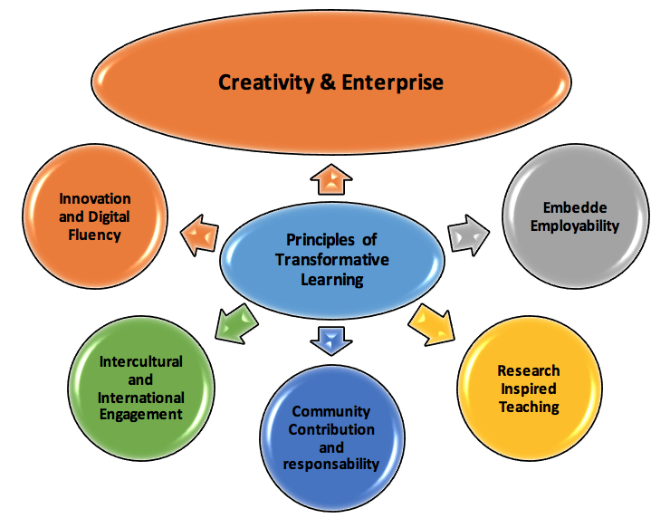

Creativity and enterprise pillar has a vital role in order to achieve our strategy goals. Without creative teaching & learning we cannot be expecting that our teaching will be inspired by teaching, or we can successfully embed employability into the University courses. Also innovation and digital fluency and how this can be injected into teaching and learning is extremely depends on the creative strategy and tactics in all aspects of teaching, learning, and assessment at the faculty levels.
Faculties CQEM reports demonstrated the significant efforts that our course leaders and course team have been doing to embed creativity and enterprise into the curriculum at course level. However, when it comes to creativity, there is always room for improvement as it has no end/limit. Below I listed a number of suggestions to maintain our faith and improve our academic practice to achieve the corporate goals towards creativity and enterprise (see figure below) and provide our students and graduates not with just their academic degree but with the tools, skills and knowledge that they could live, participate, and contribute as global citizens.

- All courses to use CDAR opportunity to embed creativity & enterprise at a course level.
- Increase the number of Add+Vantage modules to serve supporting creativity & Enterprise in each faculty
- Increase the number of targeted filed trips which are purposefully designed to promote students’ creativity & entrepreneurial skills
- Putting more focus and attention on PBL (Problem-Based Learning) activities and projects at course level based on real-world case studies for students
- Building more links and connections with local and global businesses and industries and bring more projects from industries as course projects specially at Masters and PhD levels

Useful links

http://www.osho.com/highlights-of-oshos-world/what-is-creativity
http://www.slideshare.net/HEA_AH/enterprise-in-your-degree-neil-coles-42929527

“A portfolio career involves working part-time for more than one employer or client and may include running a part-time business.” (QAA, 2012)
http://creatingbetterfutures.coventry.ac.uk/wp-content/uploads/2015/08/Creating_Better_Futures.pdf

