Time and Effort on Task - staff version  Feel free to modify for your own needs |  | 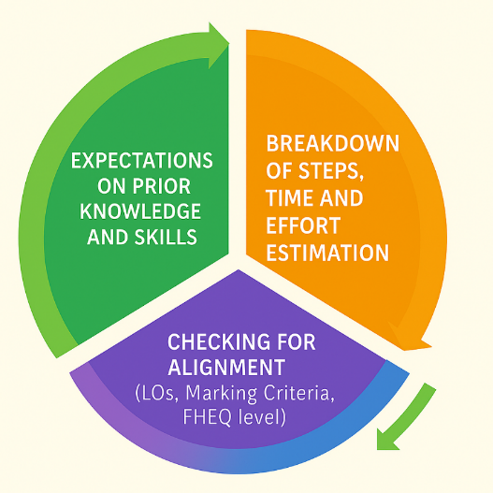
Assessment title:
Module:
Course:


This document is licensed under CC-BY-NC-SA 4.0

Developed by:
Christina Magkoufopoulou, Coventry University and Anna Law, University of the West of Scotland.
This template is an output from a Collaborative Enhancement Project supported and funded by QAA membership. The project is led by Coventry University in partnership with Aston University, International University of Applied Sciences, Germany, University of the West of Scotland, and University of West London. Find out more about Collaborative Enhancement Projects on the QAA website.


Step 1: Establishing required prior knowledge and skills

Category of prior knowledge and skills | List all relevant items | List available resources to support students – consider options from previous modules, or university-wide services
Academic Skills
Employability skills

Discipline specific skills

General knowledge

Disciplinary knowledge acquired in prior modules

Knowledge of specific tools, equipment, software required

Step 2: Breaking down of task into sub steps
(Feel free to add/remove as many steps as necessary. For each step, consider the stretch from prior knowledge and skills.)
Step | Description | Notional Time-on-Task for student performing around class average (e.g., 4-6 hours) | Relevant resources to support students
1
2
3
4
5
6
7
8
Total

Step 3: Checking for constructive alignment and compliance

Item | Yes/No | Further comments
Are the steps selected relevant to the marking criteria? Are there any steps that need to be added, altered or removed?
Are the students equipped to complete those steps? If not, are there sufficient support mechanisms in place if students need help with any of the steps?
Does the allocated amount of time align with the expected assessment credits? If not, can we make the appropriate changes?

Is this assessment task clearly aligned in terms of skills and knowledge development with prior or future assessment tasks?
Are the identified sub-steps relevant to the module and course learning outcomes?

Are the assessment demands and sub-steps aligned with the level that the students are working at?
The Frameworks for Higher Education Qualifications of UK Degree-Awarding Bodies

