Workshop to Raise Awareness of Prevent Delegate Feedback Form [ONLINE VERSION]

Please complete these questions before the WRAP workshop starts Page 1

1. Facilitator reference number (note the trainer will give this to you) | 9 | 7 | 3 | 7 | 7 | 5 | 7

2. Date of workshop |  |  | / |  |  | /

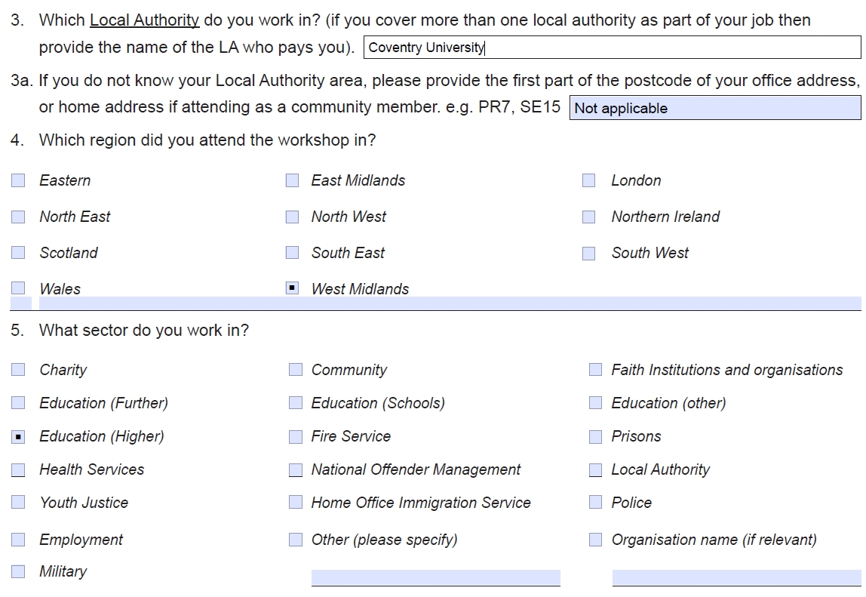
Knowledge and Understanding before the WRAP session

 | 6. How do you rate your understanding of Prevent?
 |  | No understanding |  | Poor |  | Fair |  | Good |  | Excellent

 | 7. How do you rate your understanding of how people can be influenced or radicalised?
 |  | No understanding |  | Poor |  | Fair |  | Good |  | Excellent

 | 8. How do you rate your understanding of the vulnerability factors which can lead to people being radicalised?
 |  | No understanding |  | Poor |  | Fair |  | Good |  | Excellent

 | 9. How do you rate your understanding of how to notice concerns where someone may be vulnerable to radicalisation your day-to-day job?
 |  | No understanding |  | Poor |  | Fair |  | Good |  | Excellent

 | 10. How do you rate your understanding of how to share concerns about people vulnerable to radicalisation within your day-to-day job?
 |  | No understanding |  | Poor |  | Fair |  | Good |  | Excellent

Please complete these questions after the WRAP workshop ends Page 2

 | 11. How do you rate your understanding of Prevent?
 |  | No understanding |  | Poor |  | Fair |  | Good |  | Excellent

 | 12. How do you rate your understanding of how people can be influenced or radicalised?
 |  | No understanding |  | Poor |  | Fair |  | Good |  | Excellent

 | 13. How do you rate your understanding of the vulnerability factors which can lead to people being radicalised?
 |  | No understanding |  | Poor |  | Fair |  | Good |  | Excellent

 | 14. How do you rate your understanding of how to notice concerns where someone may be vulnerable to radicalisation your day-to-day job?
 |  | No understanding |  | Poor |  | Fair |  | Good |  | Excellent

 | 15. How do you rate your understanding of how to share concerns about people vulnerable to radicalisation within your day-to-day job?
 |  | No understanding |  | Poor |  | Fair |  | Good |  | Excellent

 | 16. Do you have a better understanding of how Prevent fits into your day-to-day job?
 |  | Yes |  | No

Skills

 | 17. How would you rate your confidence in using the lessons learned in WRAP in your day-to-day job?
 |  | No confidence |  | Poor |  | Fair |  | Good |  | Excellent

 | 18. Do you feel you require any further training or support on noticing concerns related to vulnerable people?
 |  | Yes |  | No

 | 19. Do you feel that you require any further training or support on sharing concerns around vulnerable people?
 |  | Yes |  | No

Follow up:

 | We would like to contact you in 3 months time to see how useful WRAP training has been to you in your day-to-day job. If you would be happy for us to contact you in 3 months time, please supply your email address below.
 | Do you have an immediate concerns relating to vulnerability that you will be sharing following today's session?
 |  | Yes |  | No
 | Any other comments

