Time and Effort on Task - student version  Feel free to modify for your own needs |  | 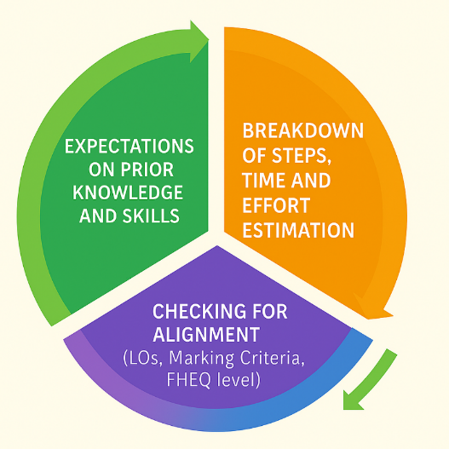
Assessment title:
Module:
Course:


This document is licensed under CC-BY-NC-SA 4.0
Developed by:
Anna Law ª, Lucie Ingram ^{b}; Gloria Oliomogbe ^{c}, Rachel J, Robinson ^{d}; Alice Lau ^{e}, Matifadza Gondo ^{f} and Christina Magkoufopoulou ^{f}
ª University of the West of Scotland, ^{b} University of West London, ^{c} Coventry University London, ^{d} International University of Applied Sciences, ^{d} Aston University, ^{f} Coventry University

This template is an output from a Collaborative Enhancement Project supported and funded by QAA membership. The project is led by Coventry University in partnership with Aston University, International University of Applied Sciences, Germany, University of the West of Scotland, and University of West London. Find out more about Collaborative Enhancement Projects on the QAA website.


Step 1: Establishing your relevant knowledge and skills

Knowledge and skills | List all relevant items | Where can I find help with this? – consider options from previous modules, or university-wide services.
Have I completed similar assessments before?
(Consider format e.g., essay/presentation and topic at any course/level)
What knowledge from the course might help me complete this task?
(Consider links with other modules too)

What knowledge from outside the course might help me complete this task?
(Consider any real-world relevance or applications of the topic)

What academic skills do I already have that can help me?
(e.g., literature searching, data analysis, or referencing)

What academic skills do I need to develop that can help me?
(e.g., literature searching, data analysis, or referencing)

Have I gained skills outside university that are relevant?
(e.g., work/hobbies can build skills in teamwork & time management)
Is there specific software, equipment or tools/resources I need to complete this task, and do I know how to use them?

Step 2: Breaking down of task into sub steps
(Feel free to add or remove as many steps as necessary)
Step | Description | Estimate your likely Time-on-Task using a flexible range  (e.g., 4-6 hours) | Estimate how much mental effort is needed  (e.g., high, moderate, low) | Target date for completion  (consider workload on other modules) | Where can I find help with this step?  (consider options from previous modules, or university-wide services)
1
2
3
4
5
6
7
Total

Step 3: Final checks for maximising success

Item | Yes/No | Further comments
Review the assessment brief. Are the steps above covering the whole task?

(Have I missed anything?)

Review the marking criteria. Will the steps above help me to meet all of them? Have I added any steps that are not relevant?

(Could I do more to maximise my grade?)

Is the total estimated amount of time realistic, for the grade I am aspiring to achieve?

(Consider how much of the module this assessment is worth – e.g., 100%, 50%, 30%?
Consider coursework demands on other modules)

Do I understand what skills and knowledge will be developed by this assessment task, to support future success on the course?

(Make a list)

